5.76: To answer the question,  must be found and compared with 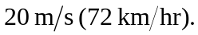 The kinematics relationship 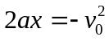 is useful, but we also need a. The acceleration must be large enough to cause the box to begin sliding, and so we must use the force of static friction in Newton’s Second Law: 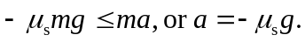 Then, 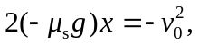 or 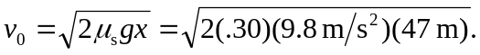 Hence, 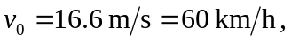 which is less than 72 km/h, so do you not go to jail.

